

**VELAMMAL BODHI CAMPUS**

**GRAND TEST-IV**

**Grade : X (Batch-II) Time Allowed : 3 Hours Subject : Social Science**  **Marks: 80**

**General Instructions:**

1. *Question paper comprises* ***Six Sections****–****A, B, C, D, E and F****. There are* ***37questions*** *in the question paper. All questions are compulsory.*
2. ***Section A*** *– From question****1 to20*** *are* ***MCQs*** *of 1 mark each.*
3. ***Section B****–Question no.* ***21 to24*** *are* ***Very Short Answer Type Questions****, carrying 2marks each. Answer to each question should not exceed 40 words.*
4. ***Section C-*** *contains* ***Q.25to Q.29*** *are* ***Short Answer Type Questions****, carrying 3 marks each.*

*Answer to each question should not exceed 60 words*

1. ***Section D****–Question no.****30to33*** *are* ***long answer type questions****, carrying 5marks each .Answer to each question should not exceed 120 words.*
2. ***Section-E****-*Question no from **34to36** *are* ***case based questions*** *with three sub questions and are of 4 marks each*
3. ***Section -F****–Question no.****37*** *is* ***map based****, carrying 2 marks from* ***History*** *and. carrying 3marks* ***from Geography****).*
4. *There is no overall choice in the question paper .However an internal choice has been provided in few questions. Only one of the choices in such questions has to be attempted.*

**SECTION – A (MCQs) 20 x 1 = 20**

**1)Who among the following led the peasant movement in Bardoli in 1928?**

a) Baba Ramachandra b) Jawaharlal Nehru c) Subhash Chandra Bose d) Vallabhai Patel

**2) Who wrote My Childhood and My University?**

a) Thomas Wood b) Maxim Gorky c) George Eliot d) Jane Austen

**3) Consider the statements, given below and choose the correct answer.**

**Statement (I): Trade and cultural exchange always went hand in hand.**

**Statement II): Buddhism emerged from Eastern India and spread in several direction through intersecting**

**points on the silk routes.**

1. Statement (I) is correct and (II) is incorrect.
2. Statement (I) is incorrect and (II) is correct.
3. Both (I) and (II)are incorrect.
4. Both (I) and (II) are correct.

**4) In Prussia who was referred to as ‘Junkers’?**

a) Military officials b) Large Landowners c)Factory Owners d)Aristocratic Nobles

**5) Identify the type of soil with the help of the following information**

i)They ranges from red to brown in colour.

ii) They are generally sandy in texture and saline in nature.

iii) Soil lacks humus and moisture. iv) After proper irrigation these soils become cultivable.

a) Laterite soil b) Arid soil c) Forest soil d) Yellow soil

**6) Bhoodan –gramdan movement was initiated by**

**a)** MK Gandhi b) JL Nehru c) Vinoba Bhave d) BG Tilak

**7) Match the following:**

|  |  |
| --- | --- |
| **Column I** | **Column II** |
| A) Chhattisgarh | i) Solar energy |
| B) Rajasthan | ii) Coal deposits |
| C) Arunachal Pradesh | iii) Cultural resources |
| D) Ladakh | iv) Water resources |

**Options:**

1. (A)-(ii); (B)- (i); (C)- (iv); (D)-(iii)
2. (A)-(iii); (B)-(i); (C)-(iv); (D)-(ii)
3. (A)-(iv); (B)-(i); (C)-(iii); (D)-(ii)
4. (A)- (i); (B)-(iv); (C)-(ii); (D)-(iii)

**8) In India seats are reserved for women in**

a) Lok Sabha b) State Legislative Assemblies c) Cabinets d) Panchayati Raj Bodies

**9) Sinhala was recognised as the only official language by the**

a) Act of 1953 b) Act of 1954 c) Act of 1955 d) Act of 1956

**10) In the question given below, there are two statements marked as Assertion (A) and Reason (R).**

**Read the statements and choose the correct option:**

**Assertion** : **Sometimes a caste group becomes** **vote bank for a party**

**Reason** : **Selecting the candidate from same caste** **helps in ensuring better governance**

1. Both assertion and reason are true and reason is the correct explanation of assertion
2. Both assertion and reason are true but reason is not the correct explanation of assertion
3. Assertion is true but reason is false
4. Both assertion and reason are false

**11. Which one of the following is a major caste group of Sri Lanka?**

a) Christian and Tamil b) Buddhist and Hindu c) Sinhala and Tamil d) Sinhala and Christian

**12) Which of the following features can be associated with the democratic government?**

a) Legitimate b) Transparent c) Accommodative d) All of these

**13) When was States Reorganisation Commission formed?**

a) 1951 b) 1963 c) 1997 d) 1953

**14) If there is a disruption by transports and lorries refuse to transport Vegetables, Milk, etc. from rural areas to urban areas ,food will become scarce in urban areas , whereas farmers will be unable to sell their products.**

**Which of the following sectors will be affected due to this situation states above?**

a) Primary and Secondary b) Secondary and Tertiary

c) Tertiary, Primary and Secondary d) Tertiary and Primary

**15) Select which among the following cannot be purchased through money. Choose the correct option.**

I. Full protection from infectious diseases II. A pollution free atmosphere

III. High quality education IV.A luxury home

a) I and II b) III and IV c) I and IV d) I and II

**16) In which of the following systems exchange of goods is done without use of money?**

a) Credit system b) Barter system c) Banking system d) Collateral system

**17) ‘A’ is a worker in a garment export industry of Jaipu**r. **He gets facilities like health insurance, provident fund**

**In which one of the following sectors is ‘A’ working?**

a) Primary sector b) Non-Governmental sector

c) Organized sector d) Unorganized sector

**18.Companies who set up production units in the Special Economic Zones (SEZs) do not have to pay taxes for an initial period of;**

a) 2 years b) 5 years c)4 years d)10 years

**19) Assume that there are four families in a country. The average per capita income of these families is**

₹**5000. If the income of three families is** ₹**4000,** ₹**7000, and** ₹**3000 respectively, what is the income of the fourth family?**

a) ₹7500 b) ₹3000 c) ₹2000 d) ₹6000

**20. Which of the following options describe dept-trap?**

a) Demand deposits with the banks.

b) Situation when it becomes impossible for the borrower to repay the loan and the borrower adds on a new debt to pay the existing debt.

c) Cheap and affordable credit.

d) Paper instructing the bank to pay a specific amount from the person’s account to the person in whose name it has been made.

**SECTION – B 4 x 2 = 8**

**II) VERY SHORT ANSWER QUESTIONS.**

21. How did the Non-Cooperation Movement unfold in the cities and towns of India?

22. Communalism is harmful for the nation. Explain.

23. Classify with the help of examples the various kinds of energy resources.

Or

What do you mean by sustainable development?

24. How is ‘double coincidence of wants’ not appreciable in the contemporary scenario.

**SECTION – C**

**III) SHORT ANSWER BASED QUESTIONS. 5 x3 = 15** 25. What were the main symbols of independent nations?

**Or**

Explain the contribution of Otto von Bismarck in German unification.

26. Elaborate the cropping seasons in India.

27. State the role of the Reserve Bank of India.

28. Describe three demands of Sri Lankan Tamils. How did they struggle for their independence?

29. Describe any four benefits of globalisation to the Indian economy.

**SECTION – D**

**IV) LONG ANSWER BASED QUESTIONS. 4 x 5 = 20**

30**.** a) Describe the impact of the Print Revolution in Europe during 15th and 16th century.

Or

b) Explain the different stages of development of printing technology in China.

31**.** a) How can the industrial pollution of freshwater be reduced ? Explain with examples

Or

b) The economic development of a country is measured by the development of manufacturing industries in the following ways:

32**.** a) Suggest any five effective measures to reform, Political Parties.

Or

1. Examine the advantages and disadvantages of two party system.

33**.** a) Differentiate between formal sector credit and informal sector credit.

(Or)

1. What are the two main reasons for formal sector credit not being available to the rural poor?

Why is there a need to expand rural credit?

**SECTION – E**

**34. CASE BASED QUESTIONS 3 x4 =12**

**Read the source given below and answer the questions that follow:** Frederic Sorrieu prepared a series of four prints visualizing his dream of a world made up of ‘democratic and social Republics’, as he called them. The first print of the series shows the peoples of Europe and America – men and women of all ages and social classes – marching in a long train, and offering homage to the Statue of Liberty as they pass by it. Artists of the time of the French Revolution personified Liberty as a female figure. She bears the torch of Enlightenment in one hand and the Charter of the Rights of Man in the other. On the earth in the foreground of the image lie the shattered remains of the symbols of absolutist institutions. In Sorrieu’s utopian vision, the peoples of the world are grouped as distinct nations, identified through their flags and national costume. Leading the procession, way past the Statue of Liberty, are the United States and Switzerland, which by this time were already nation-states.

France, identifiable by the revolutionary tricolour, has just reached the statue. She is followed by the peoples of Germany, bearing the black, red and gold flag.

Answer the following MCQs by choosing the most appropriate option:

34.1 Who was Frederic Sorrieu?

a) French artist b) German Artist c) Italian Artist d) British Artist

34.2. In which year did Frederic Sorrier prepare a series of four prints?

a) 1845 b) 1843 c) 1848 d) 1841

34.3. Which of the following statements correctly describes “absolutist”?

a) Monarchical Government b)Democratic Government

c)Uncentralised Government d) Bureaucratic Government

34.4 Which of the following is correct with respect to “utopian vision”?

a) Homogenous society b) Monarchical society c) Ideal society d) All are correct

**35. Read the given extract and answer the following questions**

Rooftop rainwater harvesting is the most common practice in Shillong,Meghalaya.It is interesting because

Cherapunjee and Mawsynram situated at a distance of 55 km.from Shillong receive the highest rainfall in the world, yet the state capital Shillong faces acute shortage of water. Nearby every household in the city has a rooftop rainwater harvesting structure. Nearly 15-25 percent of the total water requirement of the total water srequirement of the household comes from rooftop water harvesting.

**Questions:**

**35.1 Name the places which receive the highest rainfall in the world? (1)**

**35.2 Which state of India has made roof top harvesting structure compulsory to all the houses across the state. (1)**

**35.3 What is the rain water harvesting? (2)**

**36. Read the given extract and answer following questions.**

Panchayati Raj, a decentralized system of local self-governance in India, is the cornerstone of grassroots democracy. Established by the 73rd Amendment Act in 1992, it empowers villages and small towns by devolving political, administrative, and financial authority to elected representatives at the Panchayat (local council) level.  This system comprises three tiers: the Gram Panchayat (village level), Panchayat Samiti (block level), and Zila Parishad (district level). It aims to address local issues, promote rural development, and enhance citizen participation.

Panchayati Raj has not only improved service delivery and infrastructure but also empowered marginalized communities, particularly women and scheduled castes, in the decision-making process.

Over the years, Panchayati Raj has contributed to local development, social justice, and fostering a culture of democratic participation, making it an essential tool in India’s journey toward inclusive governance.

**36.1 What kind of power sharing is demonstrated by Panchayati raj system in India? (2)**

**36.2 What are the benefits of having three tier governance in the country? (1)**

**36.3 Mention some disadvantages of power sharing? (1)**

**SECTION – F (MAP SKILL BASED QUESTIONS) 5x1=5 37.a) Two places A and B are marked on the given outline map of India. Identify them and write their correct names on the lines drawn near them.**

1. The location of the Indian National Congress Session 1920.
2. The place associated with Peasants Sathyagraha.

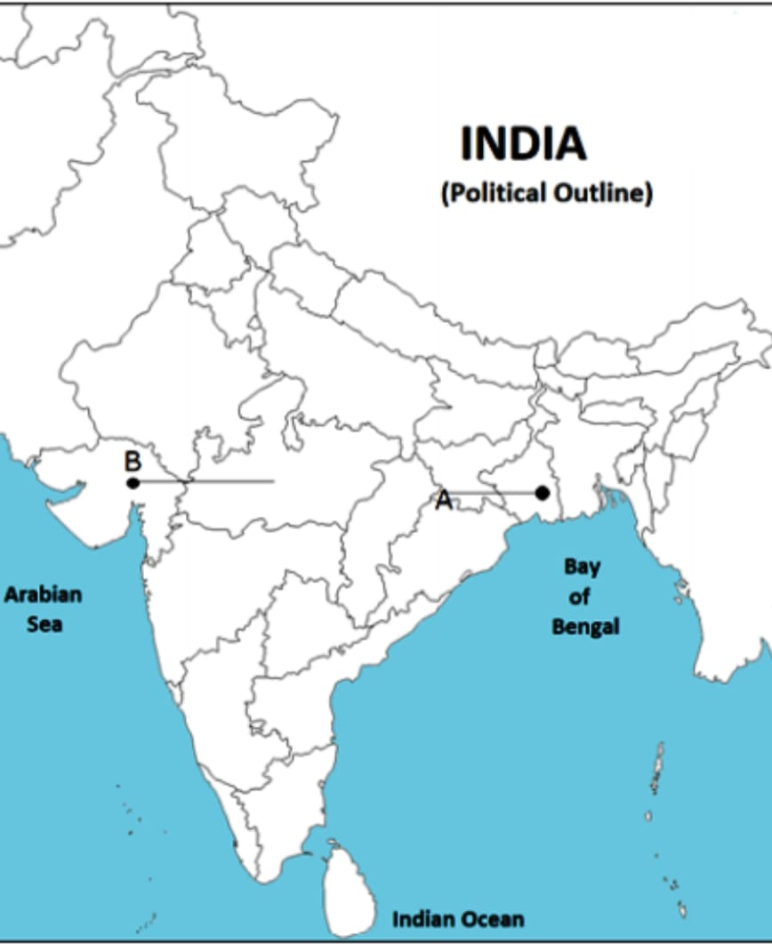

**37 .b) On the same outline map of India locate and label any THREE places with the help of the following information and write their correct names on the map.**

1)  Major jute producing state 2) Noida Software Technology park

3) Rana Pratap Sagar Dam 4) Kochi port.